

The Peoples Republic of Bangladesh
Ministry of Health &Family Welfare (Health Service Division)
Health Economic Unit (HEU). Shasta Surakkha Kormochuci (SSK)
Topkhana Road, Dhaka-1000

Visit Report: Ramgoti Upazila Health Complex, Lakshmipur
Date of Visit: 01/08/22; Time: 9:30 AM.
Visitor: Dr. Md. Mostafizur Rahman, Deputi Director (DeputySecretary)
HEU, &,
Dr. Md. Emdadul Haque, National Consultant (HEU) of MoHFW

1. The infra-structure of this Upazila Health Complex is 20 bedded but functioning as 31 bedded hospital .The building is situated close to the bank of the Meghna river. There are 8 unions under this UHC.
2.We met with the UH&FPO, RMO and other Medical Officers. anaesthesiologist, one MO having FCPS degree on Medicine, One MO having training on Gynae&Obs. for 18 months and a Dental Surgeon. We discussed with them about the overall situation of health complex.
3. One union is an island named Chor-Abdullah having population about 15,000. There is no sub-centre, H&WC or community clinic at that island. One HA & one FWA is working there. The distance of the island is nearly 15-20 km from main land. The only transport they have is an engine boat and which takes nearly 2.5 hours to cross the river.
3. We visited outdoor of the Upazila Health Complex of Ramgoti. The outdoor was over crowded with patients. We observed OPD services, dental outdoor, X-Ray, pathology and pharmacy department and 24/7 blood transfusion system. There is no medical technologist (Lab), but a MT (T.B) working as MT (Lab). The information display system was weak, no health education system existed there.
4. Cleanliness of the indoor was not satisfactory. No separate operation theatre and labor room is using as operation theatre.
5. There is beautiful garden in front of the hospital.
6. Cycle stand is away from the main gate.
7. Waste management system is weak. The posterior side of the hospital is unclean.
8. Ante-natal servics was not satisfactory . Thre is no facility of C-sction but total NVD was 98 in June 22.
9. The position in health service system (HSS score) was 219 in May-22 and 212 in June-22 among all the UHC of the country.
10. In June-22, the bed occupancy rate in was 100.25%, OPD patient was 7,263.

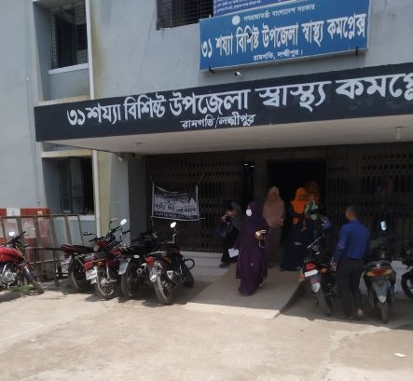
Fig-1: Front side of Ramgoti UHC, Lakshmipur

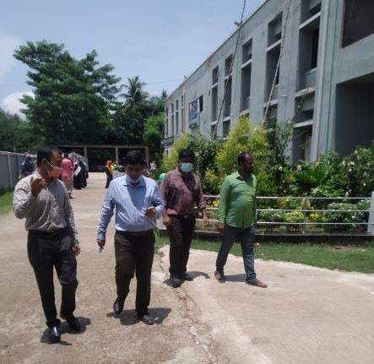
Fig-2: Beautiful garden in front of UHC (Good practice)

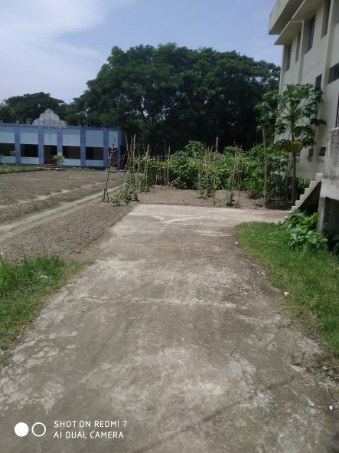
Fig-3: Residential area of the hospital is being used as vegetable garden
(Good Practice)
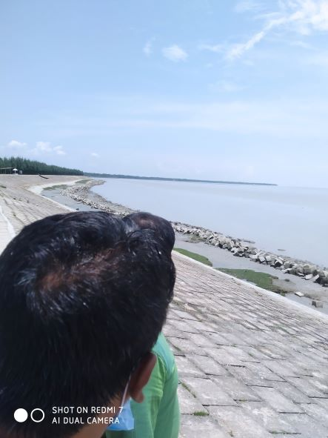
Fig-4: Ramgoti UHC situated in the bank of Meghna river. Part of the
baribadh with in the area of the UHC.

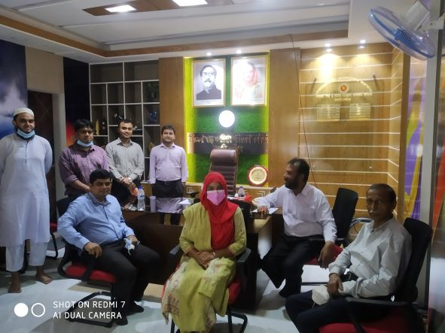
Fig-5: The room of UH&FPO is well decorated (Good practice)

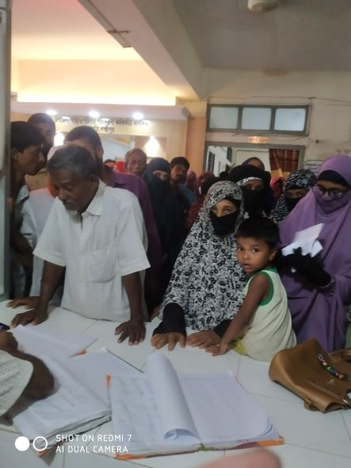
Fig-6: Overcrowded and no queue in ticket counter

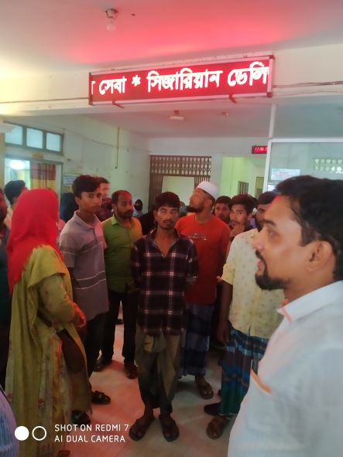
Fig-7: Digital display of health message (Good practice)

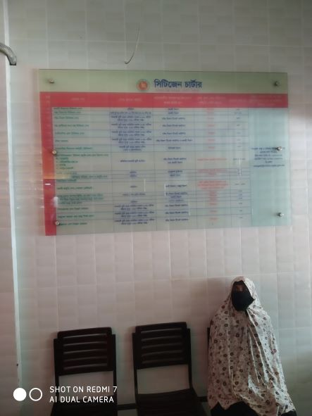
Fig-8: Beautiful display of Citizen charter (Good practice)

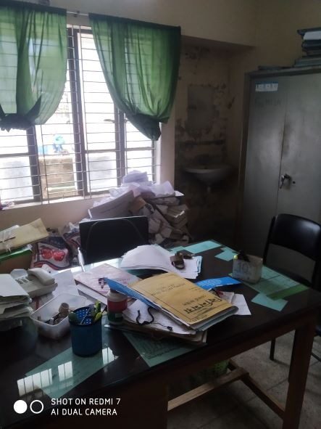
Fig-9: Disorganized office file management

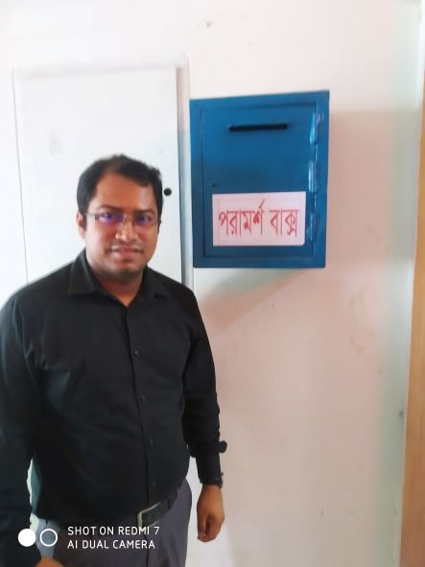
Fig-10: Suggestion box (Good practice)

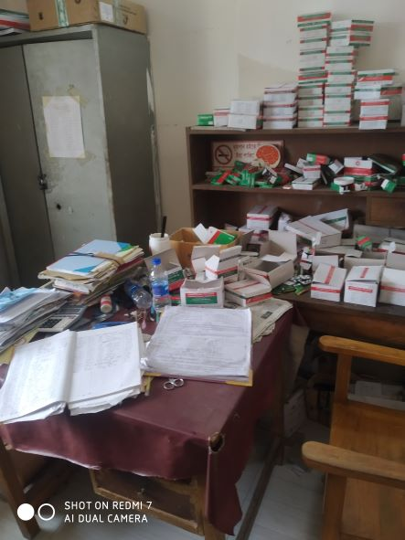
Fig-11: Disorganized Pharmacy

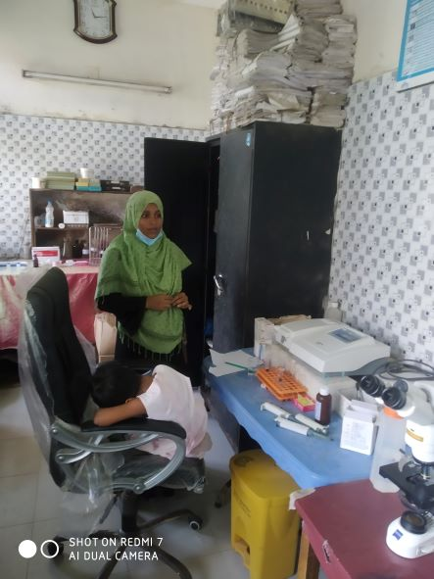
Fig-12: Disorganized Pathological Lab

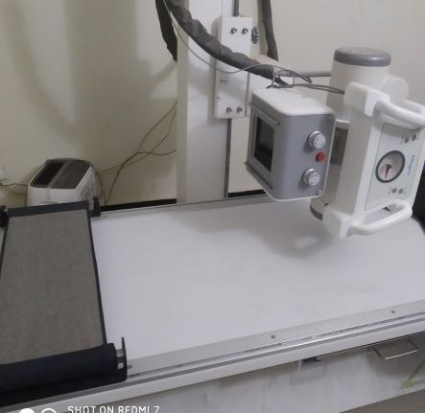
Fig-13: Functioning X-ray machine

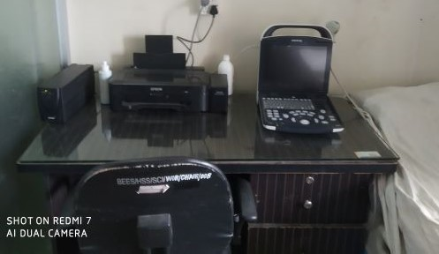
Fig-14: Functioning USG machine
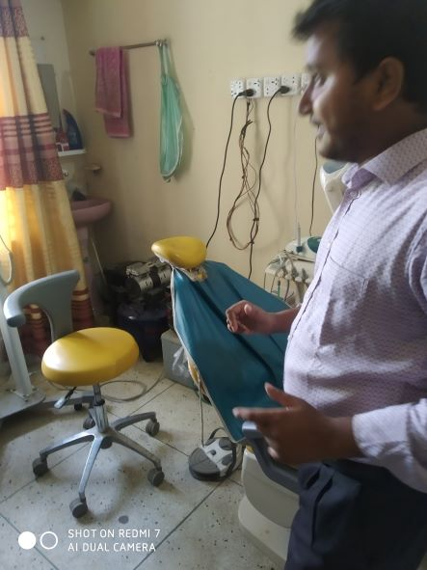
Fig-15: Functioning Dental unit with dental X-ray facility

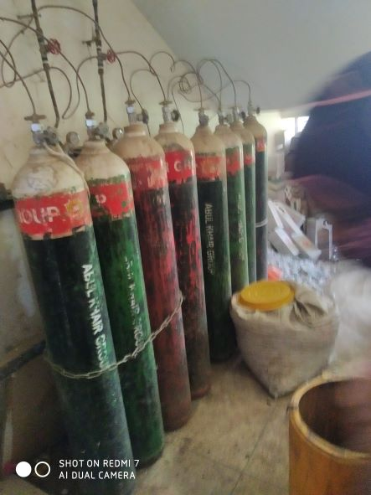
Fig-16: Central O₂ supply system with donated by Abul Khayer Group

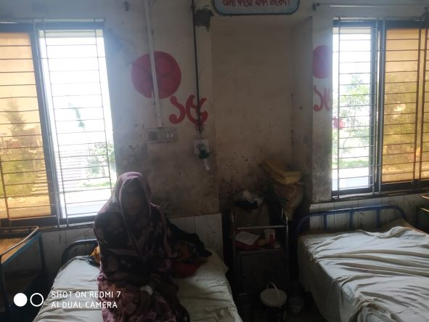
Fig-17: Unclean female indoor

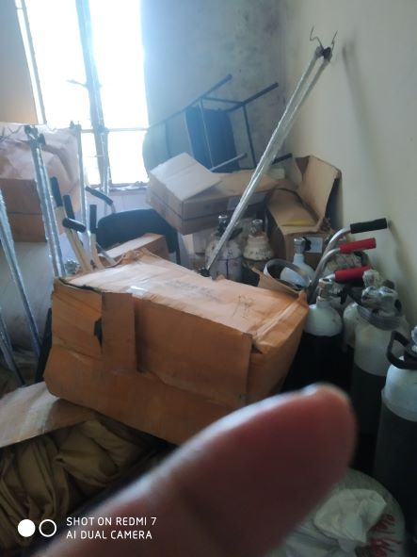
Fig-18: OT room is being used as store

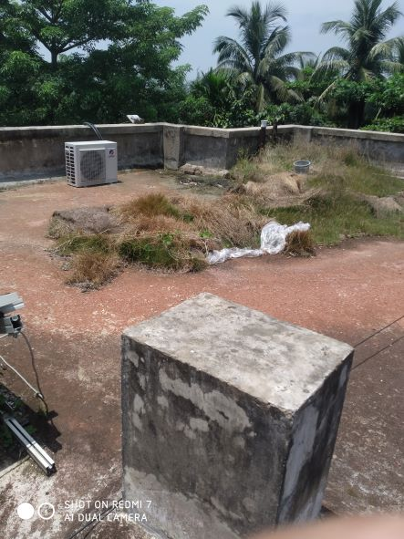
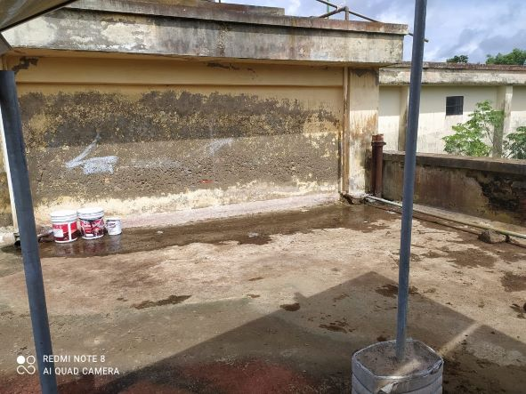

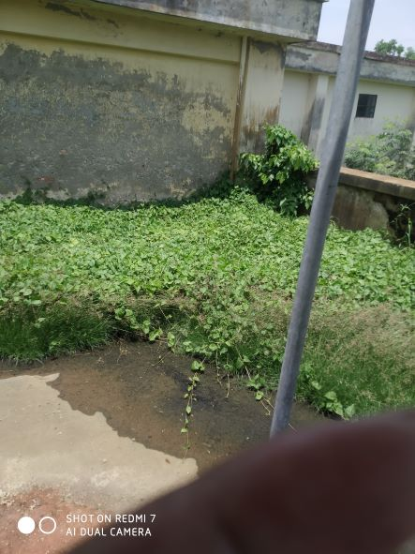

Fig-19,20: Rooftop of the building is mismanaged and filled with shrubs

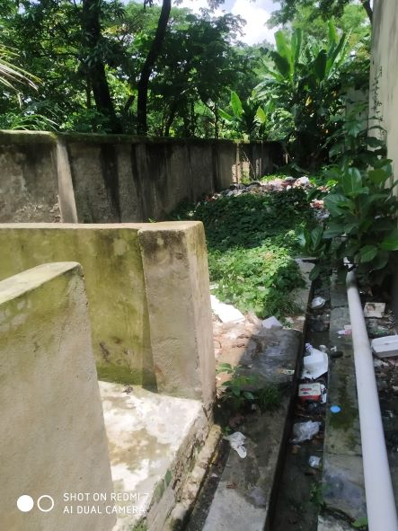
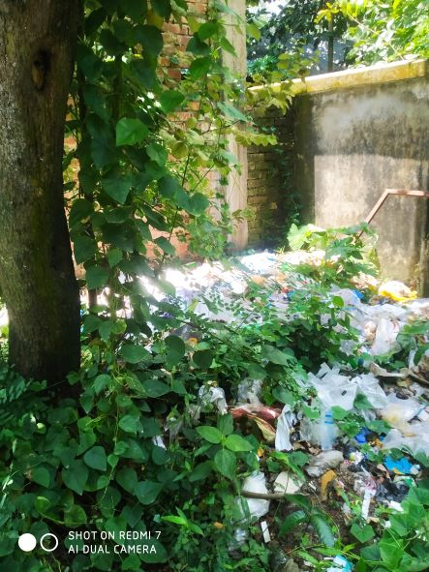
Fig-21,22: West side of the hospital is filled with hospital waste materials

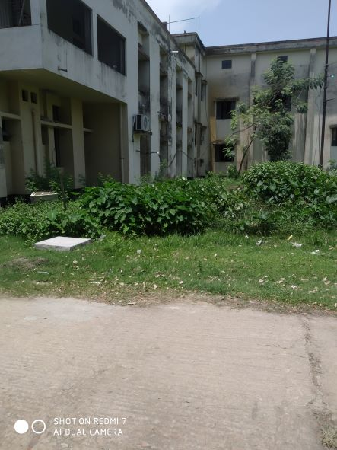
Fig-23: Backside of the health complex building

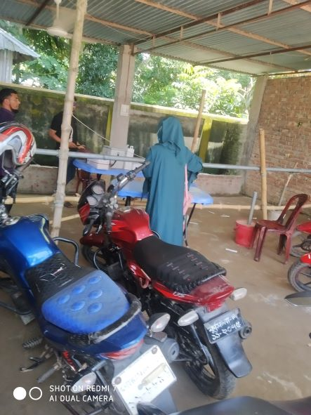
Fig-24: Cycle stand is far from the main gate

Health Profile of Ramgoti UHC, Ramgoti, Laxmipur
Total population: 2,30,000
Union: 7 Sub-centre: 2 FWC: 5 Community Clinic: 20
Human Resources: 31 Bedded Hospital:
Sl. | Designation | No. of Post | Present | Vacant
1. | UH&FPO | 1 | 1 | 0
2. | Junior Consultant: Medicine, Surgery, Gynae, Anestheology & Rheumatology. | 5 | 1  (Anesthesiology) | 4
3. | Medical Officer | 2 | 1 | 1
4. | Medical Officer (OSD) | 8 | 5  1 deputation,  2 work in Sub-centre | 0
5. | Nurses | 26 | 9  1 deputed in Dist. Hospital | 15
6. | Mid wives | 4 | 0  (2 deputed from Dist. Hospital) | 4
7. | Medical Technologist (Lab) | 3 | 1  (MT-TB) | 2
8. | MT EPI | 1 | 1 | 0
9. | Dental Technologist | 1 | Deputation in Dhaka Dental College | 0
10. | MT (Radiology) | 1 | 0 | 1
11. | SACMO | 9 | 8 | 1
12. | Health Inspector (HI) | 2 | 0 | 2
13. | Assist. Health Inspector | 9 | 6 | 3
14. | Health Assistant | 43 | 22 | 21
15. | CHCP | 20 | 18 | 2
16 | Head Assistant | 1 | 0 | 1
18. | Accountant | 1 | 1(In charge of Head. Asst &statistician) | 0
19. | MLSS | 4 | 0 | 4
20. | Cleaner | 5 | 2 | 3
21. | FWA | 36 | 26 | 10
 | Outsourcing: Cleaner, Cook, Guard, Ward boy, Aya. | 5(1+1+1+1+1) | 5 (Joined from 10/5/22) | 0

Human Resources: 20 Bedded Hospital
Sl. | Designation | No. of Post | Present | Vacant
1. | RMO | 1 | 1(Deputation at Chittagong Medical College) | 0
2. | Consultant | 4 | 0 | 4
3. | Medical Officer | 1 | 0 | 1
4. | Lab Attendant | 1 | 1(Deputation in Sadar Hospital)
5. | MT Lab | 1 | 0 | 1
6. | MLSS | 2 | 0 | 2
7. | Pharmacist | 1 | 0 | 1
8. | Office Assistant | 1 | 0 | 1
9. | Head Assistant cum Accountant | 1 | 0 | 1
10. | Cleaner | 1 | 0 | 1
11. | Word Boy | 2 | 2 (1 deputation in Dist. Hospital) | 1
12 | Night Guard | 1 | 0 | 1
13 | Cook | 1 | 0 | 1
14 | Aya | 1 | 0 | 1

Status of Building Blocks of C-J Model in the Ramgoti UHC:
Sl | Criteria of C-J Model | Best | Good | Weak
 | Cycle stand close to the main gate |  |  | √
 | Health Education |  | √
 | Cleanliness & beautification |  | √
 | Separation of patients in out door & indoor |  |  | √
 | Blood doner list with 24/7 B.T facility |  | √
 | Birth- death recording |  |  | √
 | Reception Desk |  |  | √
 | Developed Emergency Dept. |  |  | √
 | 5S –KAIZEN implementation. |  |  | √
 | Community Participation. |  | √
 | Hospital activities Display |  |  | √
 | Corner based service. |  | √
 | Cash counter for receiving Govt money. |  |  | √
 | Devolped maternal health/labour word. |  | √
 | Devolped paediatric health |  |  | √
 | Position in HSS score  (Best= <100; Good= 101-200; Weak= >200) |  |  | √
 | Power point Presentation &Video on UHC |  | √
 | Knowledge about 8th Five Year plan & SDG. |  |  | √
 | Zero-Tollarance on corruption |  | √

Status in HSS Score From Jan-July.
Name | Janu | Feb | Mar | April | May | June | July
Lakshmipur D-Hospi | 02 | 01 | 02 | 02 | 03 | 03 | 55
Ramgati UHC | 198 | 117 | 96 | 265 | 219 | 212 | 356
Ramganj UHC | 31 | 04 | 13 | 75 | 83 | 120 | 364
Raipur UHC | 87 | 121 | 127 | 306 | 228 | 92 | 358
KamalnagarUHC | 154 |  | 59 | 176 | 168 | 289 | 385
 | - | - | - | - | - | - | -

Recommendations:
1. The present RMO is deputed at Chittagong Medical College. One medical officer is in charge of RMO. Since the RMO position is a crucial one, it should be immediately filled up by another RMO.
2. For better office management, the post of Head Assistant and Statistician is very important. Both the post is lying vacant. It should be filled up immediately.
3. Cleanliness and beautification is not upto the mark. The local Powroshova must take part in waste management.
4. Patrients accomodation is a serious crisis and need immediate infra-structure development (either by vertical extension or by building of 50 bedded infra-stucture).
5. There is no OT room in the health complex. Labor room is also using as OT. Store room should cleaned and make as usable for OT.
6. Condemetion Board should work to destory all unwanted items.
7.All the vacant posts of 4th class should be fulfilled immediataely.
8. Minimum two (2) Medical Technologist (Lab) is necessary for pathology & Blood transfusion and they should be posted the rspective positions immediately.
9. Replication of C-J model will help in development of the quality of care and it should be followed properly.
10. Unification of human resource of 20 bedded hospital and 31 bedded hospital Iurgently needed and neceesary actions should be taken without further delay .
11.The post of Gynae consultant and all the post of midwives should be filled up immediately . Obstetric operation is going on by local arrangement by Civil Surgeon Lokhmipur.
12. Radiogical service is going on but it should be digitalized.Vaccant post of radiographer shoul be fulled.
13. Char Abdullah should be taken under special consideration and to ensure proper health services there -safe and quick commucation system must be established. For which “Water Ambulance Service or Air ambulace” must be engaged for this purpose.
14. Suggestion box should be replaced by a Complaint and suggestion box.
15. To prevent radiation protective shield for dental surgeon should be given as he performing dental X-Rays.

The report is reviewed by-
- Md. Shahadat Hossain, PhD - National Consultant

